The Results of the Premier Medicine Practice Survey 2021
Why 1. to gauge where we are not performing as well as we should in the eyes of the patients.
2. to plan improvements
3. to address concerns
We took the RACGP survey and converted it into a Survey Monkey survey as this was conducted during the pandemic. Over 200 questionnaires were sent via email to a random sample of our regular patients. Only 35 were returned. All replies are anonymous so people felt they could answer freely
We analysed the responses of those surveys utilising Survey Monkey.

Results
Everyone felt they could see the doctor of their choice
Wait times all were scored as good or very good. This has improved since the last survey was conducted 3+ years ago. The appointment times were lengthened to 20 minutes in line with the Level B length so that people were not kept waiting. This has been a successful change.
Most people were satisfied with the experience at the surgery although 2/35 scored this as poor. A number scored it as excellent (17%).
Time taken travelling to the clinic was mostly experienced as good or excellent. We are situated in a suburban area where there are a number of medical practices so people have a choice to visit any one of a number of practices which could possibly be closer to their homes but have chosen to travel to attend our practice.
Parking should be very easy in out location as we are next to Westfield to our South which affords level covered access; and another municipal car park to our North which is 150m level walk. There is also metered street parking and disabled parking spots immediately outside with level access. Despite this one person scored the ease of parking as poor.

Everyone felt the reminder system for appointment was very good or excellent except for 5 people who said it was good.

One person felt the waiting comfort level was poor, 7 felt it was good and the remainder felt it was very good or excellent. Our waiting has padded chairs which are socially distanced from each other. There is a TV which has medical information broadcast and another which has a news channel. Before COVID we offer toys and a play area for children with age-appropriate drawing materials. For adults we offered free tea and coffee from a Nespresso machine + the daily newspapers and a selection of magazines. Cold water was available for everyone. Since COVID struck all of those facilities have ceased.

Question 2
2 people felt our staff were good at welcoming them 80% felt our staff were excellent.
85% felt their level of professionalism was excellent.
71% felt that their needs were handled excellently when trying to make an appointment.
One person felt that a delay was communicated poorly, 4 felt it was handled well. Everyone was else felt that this was handled very well or excellently.
Everyone felt hat they were delate with in a courteous and polite fashion with only 3 people scoring our staff as very good and everyone else as excellent
Those with children felt similarly.
Question 3
The communication with physicians was also well regarded by our patients, with everyone scoring the doctors treating the patients with respect as excellent apart from 3 people and one n/a ???
As similar respoense wasreceived in regard to understanding of personal circumstances.
One person felt we didn’t have enough time to discuss the problem at hand. 77% scored this as excellent, the rest as very good.
The result was the same in regard to answer to how the doctors regarded the patient as a person.
All bar 4 people felt that the doctors made them feel exceedingly comfortable and the rest scored their experience as very good and one as good.
Similar results were received in answer to the question was the patient shown sensitivity to their concerns.
Everyone felt that we had told them all they wanedt to know about their condition in an excellent fashion, 6 felt we had done so very well and nine failed to answer.
I regard to alternative therapies this was not relevant for 20% of the sample, 5% felt that this was ahndel well – and they others very well, or excellently (63%).
Qyestion 4
At the last visit the patients felt they had enough time for the doctor to listen to what they havd to say. In that 83% scored their experience as excellent.
Helped them undetsandt their medical consition 83% of the time.
In all cases felt they the purpose of any tests and treatemnst were explained very well or excellently eveby all pateints.
All pateinst bar one who scored n.a and 3 who scored very good felt the doctors were excellent in involcvung he patient in the decision making rcess in regard to their treatment

A similar response was delivered to us when asked if they understood what to do when they went home.
When asked how the doctors accepted the decision of the patient to seek further treatment all scored as very good or excellent when it applied to them apart from one person.

One person felt that our performance was poor in discussing their personal issues two answered the question n/a, and 83% felt our ability to discuss their personal issues was excellent.
When appropriate all patients felt that we had guided them very well or excellently on how to take their medication.
For those where tests were offered all patients felt that the doctors had given the patient the final choice to make. Mostly in an excellent fashion.

A similar response was returned in relation to choosing treatment options.

83% felt that the doctors were excellent in the way that they listened to what the patient had to say.
Question 5
80% of patients felt that the amount of useful information given about their condition was excellent.
A similar response was received in regards to their treatment.
All bar 3 people rated the doctors as excellent in delivery of information in regard to medications. 4 people marked this as not applicable to them.
The same number of respondents indicated that delivery of information re side effects of treatment very good or excellent.
In regard to delivery of information as to how to stay healthy all bar two marked this as excellent 83%,or very good.
80% of patients felt that our delivery of health information in regard to future healthcare was excellent.
88% felt that we gave useful written information with a rating at least ‘good’ and mostly ‘excellent’
In relation to accessing information in the internet for 42% this was not applicable for the rest one rated us as poor the rest as excellent or very good.

I regard to privacy in the waiting area the last visit on person rate us as poor in this regard and the others as follows 2 n/a the rest good -> excellent. This is an area upon which we would struggle to improve. As necessarily there are other people present. We have a small waiting area and as we book every 20 minutes not too many people are present at any one time. Should the staff notice someone is distressed or unwell they are politely invited to sit or lie down in our treatment room.
In regard to privacy of the examination 88% rated us as excellent one n/a and three very good.

In regard to being able to discuss matters which were personal 91% of respondents rated us as excellent.
In regard as to their knowledge as to how medical records were kept in the practice 25% had little idea. We are a fully computerised practice.
In regard to our communication with other practitioners all bar 5 rated us as good, very good or excellent 3 n/a.
WE explained electronic medical records well in all cases bar 3 and a firtjer 3 maked the question as n/a.
I requesting for another practitioner to join the appointment one person marked this a poor 11 =n/a two very good and the rest excellent. We request written permission form each patient to have a student join the consultation and they are told that they have the right to refuse without reason needing to be given.

Question 7 How your clinican worked with other healthcare professionals
Re Medical history
Re advice received form other health professionals
gave you options for specialists or other healthcare provider
coordinated different healthcare professionals
allowed you to have the final choice about which other professionals you saw
gave the right amount of information to other healthcare professionals
In all parameters 3 people wrote n/a , 71% scored as excellent in all parameters the remainder as very good

Question 8. thinking about your experience with the general practice over the past year

suitability of opening hours - All felt our opening hours were very good or excellent except for one person – NB we are open from 8am -6pm Monday -Friday and two Saturdays a month
being able to see a doctor at the clinic when you needed urgent care -2 people scored this as good everyone else as excellent or very good 8 people n/a
being able to see the doctor of your choice- predominantly excellent one n/a and 3 very good
information about how to get medical care when the clinic is closed -n/a=8 rest good =4 rest verygood or excellent
the amount you paid for each visit to the doctor- one felt this was poor 2 fair the rest was very good or excellent
contacting a physician by email – 88% staed that this was a very good or excellent experience

being able to receive a home visit by a doctor – We generally do not provide home visits except to nursing home patients or to those who are very unwell despite the majority scoring this as n/a 6 scored this as very good or excellent
providing your test results in an understandable way – 85% scored this as excellent the remainder as very good

Question 9
The sample was 40% male 60% female
Question 10
Have you been to another general practice in the last year – 45% had – NB this survery was conducted during COVID so many would not have been able to travel for part of the time and might have received a vaccination elsewhere.
Question 11
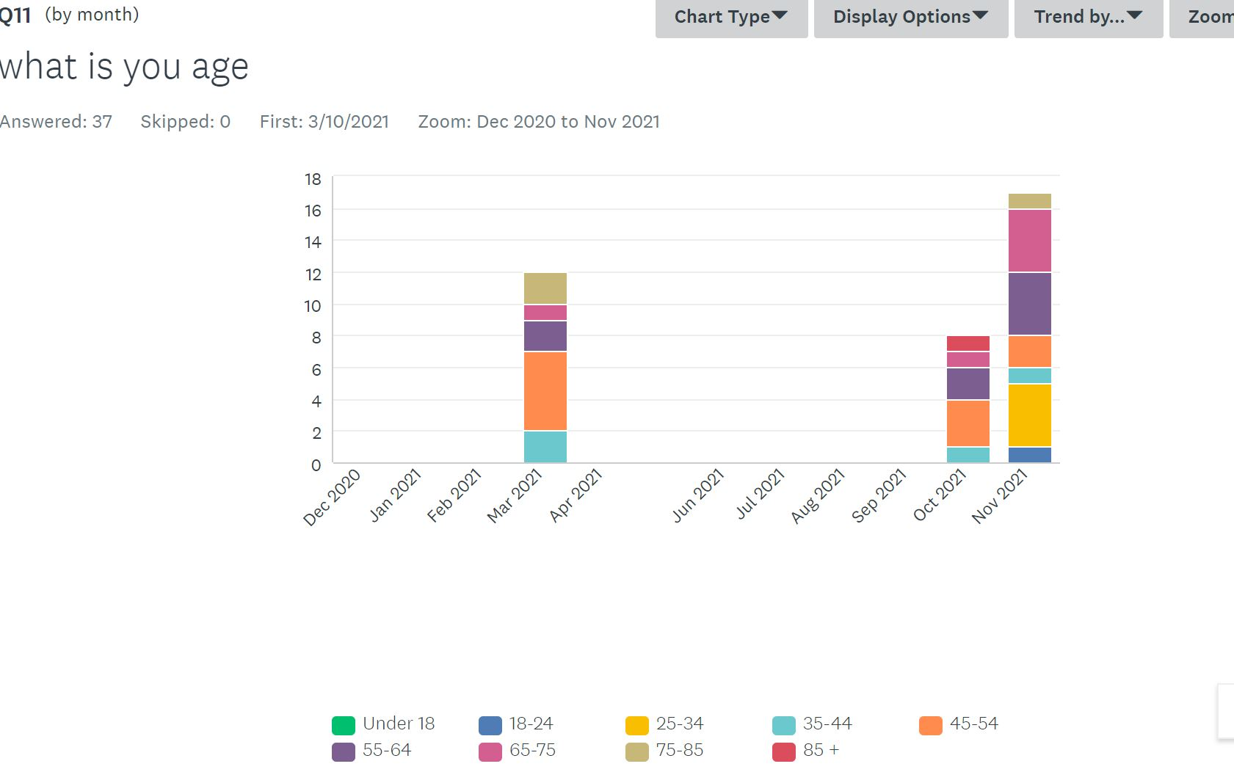
Question 12
None of the respondents identified as Aboriginal or Torres Straight Islanders

Question 13

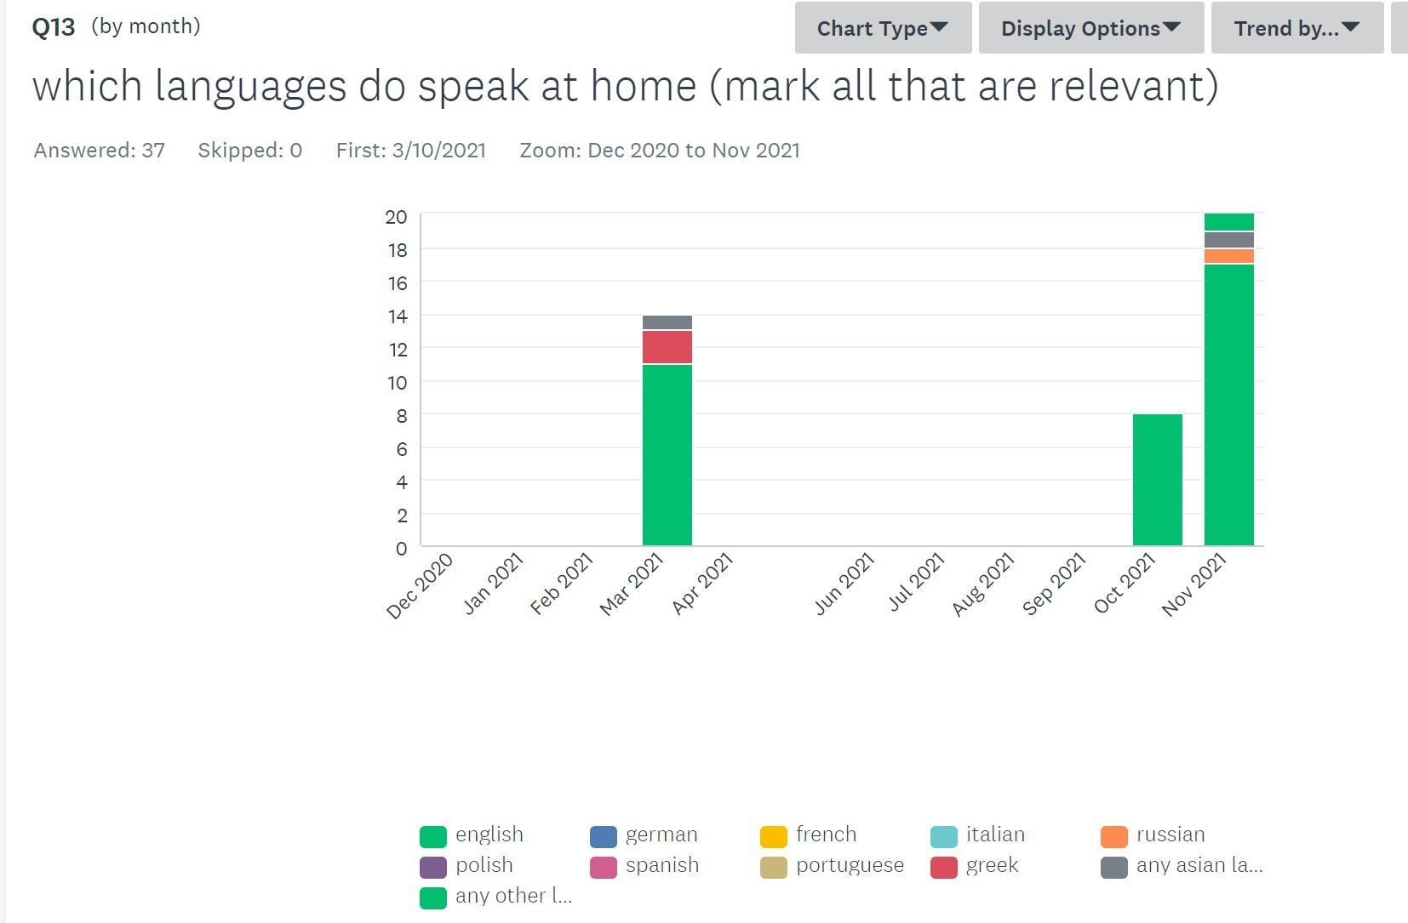
Question 14
The majority of patents had been attending the practice for over 3 years
Question 15
Visit numbers in the last year
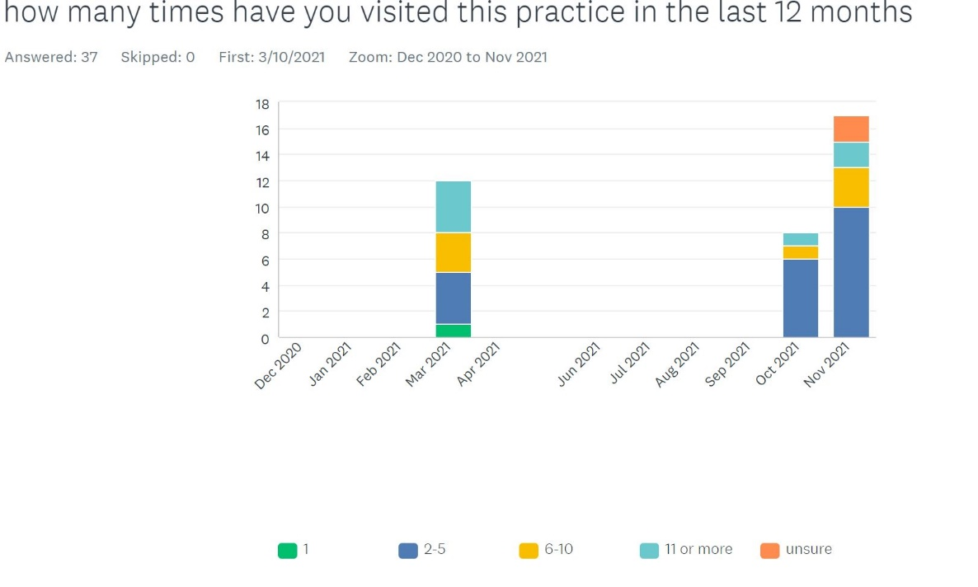

Question 16
Education level everyone had competed high school and the majority had attended Tafe or university on person was still studying
Question 17
Concession card holders – 13 had a Healthcare ard, one was one Veteran’s Affairs, 4 had a Pension card
Question 18
The patient’s regular GP was Dr Whiteson
Question 19
have you seen any of the other practitioners at this practice?
71% had seen the phlebotomist, 6 had seen the physiotherapist, 2 the psychologist and 3 the dietitian.
CONCLUSION
The sample collected was small despite approaching over 250 people to complete the survey. Due to the restrictions of COVID the survey had to be conducted on-line rather than handing people something to complete at the practice.
The responses received were favourable and I think as a team we can be pleased with the results.
In regard to improvements we can make – we can always improve always listen more to our patients needs and try to be the best team we can be.
FUTURE PLANS
Before COVID we lost our physiotherapist and we might consider replacing this person in our team.
We could think about engaging another doctor in addition to the two we currently have on staff.

